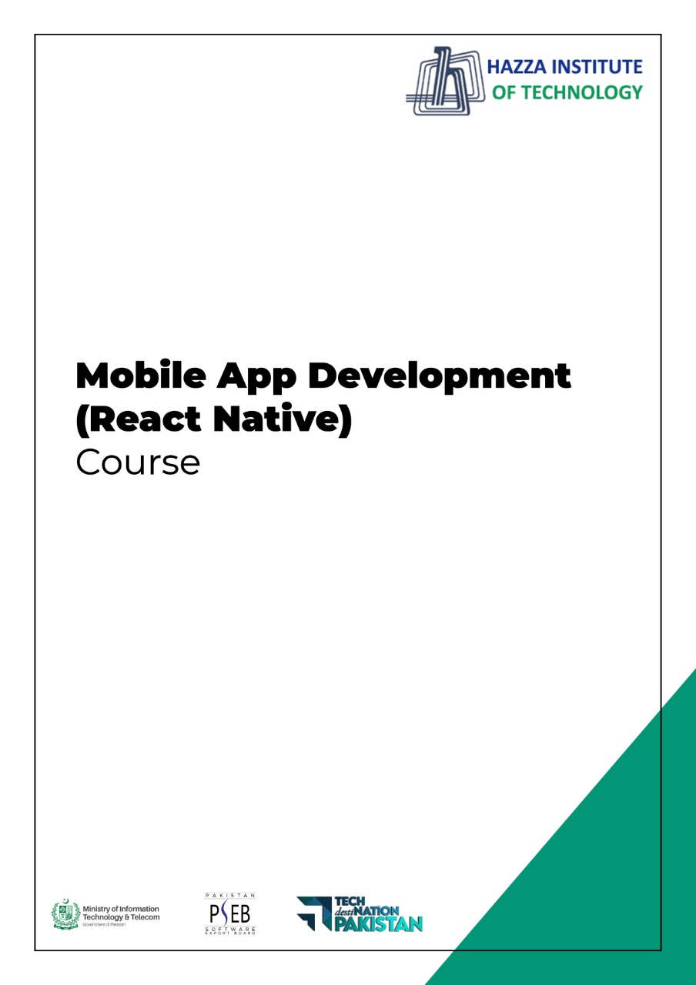

**(React Native)**

Term 2 Paper

**TERM 2 PAPER**

Total Marks; 100

Q1: Is React Native hard? (20 Marks)

Q2: How many types of threads are in React Native? (20 Marks)

Q3: Why do we use StyleSheet.create? What are the tradeoffs with this approach? (20 Marks)

Q4: Describe advantages of using React Native? (20 Marks)

Q5: Which IDE is used for React Native? (20 Marks)

Or

Q6: Is ReactJS same as React Native? (20 Marks)